A000-AM,S-Argentina-Tucumán Province-Bifacial Projectile Points-Intihuasi Tradition-Archaic-Obsidian-6000 BCE

* 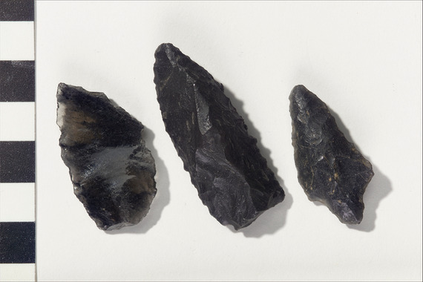
* AM,S-Argentina-Tucumán Province-Bifacial Projectile Points-Intihuasi Tradition-Archaic-Obsidian-6000 BCE

Case No.: 14

Accession No.

Formal Label: AM,S-Argentina-Tucumán Province-Bifacial Projectile Points-Intihuasi Tradition-Archaic-Obsidian-6000 BCE

Display Description:

These obsidian points display three characteristics. First they are all of the presumably same obsidian but the points are all of varying types. This indicates obsidian was the preferred raw material for all of these types. Secondly the hafting is different for all three types, and since they were found together it suggest that the flint knappers were experimenters. Thirdly, since projectile point designs are usually very conservative, these flint knappers to have been among the first to initiate these types.

Date or Time Horizon: 6000 BCE

Geographical Area:

Map:

GPS coordinates:

Cultural Affiliation: probably Intihuasi Tradition (archaeological culture) (attributed)

Media:

Dimensions:

Weight:

Condition:

Provenance: Collection history unknown, but possibly collected or excavated by archaeologist and entomologist Dr. Carlos Bruch (1869-1943); formerly in the collection of the Field Museum of Natural History (Chicago, Illinois); acquired by MAI via an exchange with the Field Museum in 1918.

Catalog number: 8/7072

Discussion:

References:

Object name:

Bifacial tool/projectile point

Date created:

6000-2000 BC

Place:

Tafí del Valle Department; Tucumán Province; Argentina

Media/Materials:

Stone

Techniques:

Flaked/chipped

Collection History/Provenance: